**General introduction**

St. Bavo's Cathedral houses an impressive collection of art and architectural treasures. The chancel and the ambulatory chapels date from the Gothic period. The chapels were renovated in the Baroque style following the Iconoclastic Fury. The decoration was largely financed with donations from bishops, rich patricians, the guilds and other wealthy benefactors. The names of the donors and their coats of arms can be found in each of the fourteen chapels.

Another emblem that can be seen in various places is the emblem of the cathedral chapter: a phoenix with the motto ‘God doet meer’(‘God does more').

The art treasures are ordered according to their location in the cathedral: the chapels of the ambulatory, the chancel and the nave. In this text, in addition to the Lamb of God itself, there are three ‘don’t miss’: the Rubens Chapel, Triest's ceremonial tomb and the candlesticks.

**A. The ambulatory chapels**

**(1) Rubens Chapel DON’t MISS**

This chapel is so called because it contains one of the most important masterpieces of the Baroque artist Pieter Paul Rubens, The conversion of St. Bavo. The composition is lively and colourful, and Rubens regarded it as one of his finest works. It was commissioned by bishop Carolus Maes, but was only completed in 1624 during bishop Antonius Triest's period of office. Rubens added Triest's coat of arms in the bottom left corner. On the opposite wall hangs a painting by Otto Venius, depicting The raising of Lazarus. Venius was once Rubens' teacher, but his painting, fine though it is, is overshadowed by the virtuosity of his pupil.

**(2) Portraits of the cathedral's bishops**

Portraits of the various bishops and auxiliary bishops.

**(3) Portraits of members of the chapter of St. Bavo's**

Portraits of members of the chapter of St. Bavo's, who became bishops elsewhere.

**(4) and (5) Priest's Chapel & Bishop's Chapel**

It was in the Priest's Chapel, with its massive openwork copper doors, that the priest usually heard confession. If however, the sins were particularly bad, forgiveness could only be granted by the bishop in the Bishop's Chapel. Bishop Triest purchased this chapel, with its great bronze doors and an altar designed by Rubens, from the baker's guild. The Gothic wrought-iron chandelier with a dragon is one of the few surviving objects that were transferred from St. Bavo's Abbey.

**(6) Chapel of the Blessed Sacrament**

The Lamb of God

**(7) Vyd Chapel**

This is the chapel where the Lamb of God was first installed in 1432. When painting the shadows on the altarpiece, the van Eyck brothers took account of the natural fall of light from the two large windows in the chapel's southern wall. The painting stayed here until 1985. The space where it once stood is now occupied by an open frame with the same contours as the altarpiece, a work by contemporary artist Kris Martin. The stained glass windows contain the coats of arm of the Borluut and Vyd families. Joos Vyd's coat of arms can also be seen in the capstone. This stone is at the centre of the ceiling in the Vyd Chapel, where the ribs of the vault meet.

**(8) Viglius Chapel**

The burial chapel of Viglius Aytta contains the Viglius triptych by Frans Pourbus the Elder, a symbolic representation of the religious and political differences that existed at the time it was painted. The central panel depicts Jesus amongst various scholars and historical figures, positioned to reflect their beliefs. On the left, stands Viglius with his red robe and white beard, accompanied by others who have remained true to the Catholic faith and the Spanish Empire, like Charles V. On the right stand the Protestant reformers, including Calvin. The wings depict the circumcision and baptism of Jesus.

**B. Chancel**

**(9) Main altar and ceremonial tombs**

The 18-meter high marble main altar depicts the glorification of St. Bavo. At the centre, the saint stands on a cloud, surrounded by angels and beams of heavenly light. To the left and right are the ceremonial tombs of four Ghent bishops.

**(10) The ceremonial tomb of bishop Antoon Triest DON’t MISS**

Triest's impressive ceremonial tomb in black and white marble was sculpted by Jérôme Duquesnoy.

**(11) Candlesticks DON’t MISS**

The four monumental bronze candlesticks, made by the Italian Benedetto da Rovezzano for King Henry VIII of England, were bought by Triest during the English Civil War. Copies now stand in St Paul's Cathedral in London. Triest had his coat of arms engraved in the bases of the originals.

**(12) Choir stalls & grisailles & coats of arms of the Golden Fleece**

Above the prestigious mahogany choir stalls a series of grisailles depict scenes from the Old and New Testaments. Above the grisailles hang the 38 coats of arms of the knights in the Order of the Golden Fleece. They were installed as decoration for the stalls on the occasion of the historic seventh chapter meeting of the Golden Fleece on 6, 7 and 8 November 1445. The southern part of the nave contains the blazons of the final chapter meeting of the Golden Fleece, held here in 1559.

**(13) Organ**

There are four organs in the cathedral: two in the cathedral itself and two smaller, more modern instruments in the crypt. This is one of the two organs in the cathedral itself, purchased by Bishop Coppieters in 1935. It was built on the left side along the gallery above the choir stalls in the chancel. It was built by the German organ maker Klais for the World Exhibition in Brussels that same year. It is the largest organ in the Benelux.

**C. Nave**

**(14) Organ**

The second organ in the cathedral was commissioned by Bishop Triest in 1653 from Bis and Destré in Lille. It is still in its original location: the left transept.

**(15) Coats of arms of the Golden Fleece**

These 51 blazons were installed on the occasion of the twenty-third and final chapter meeting of the Order of the Golden Fleece.

**(16) Pulpit**

The monumental pulpit by Laurent Delvaux is one of the finest examples in the Rococo style. The combination of dark oak and white marble exudes strength. The elaborate decoration depicts the heavenly glory of the hereafter. The theme is 'truth'.

**(17) and (18) Stained-glass windows**

Most of the windows date from the second half of the 19th century. The two most striking exceptions are opposite each other: on the left, four original fragments from the 16th century (17); on the right, the contemporary window by Harold Van de Perre (18).

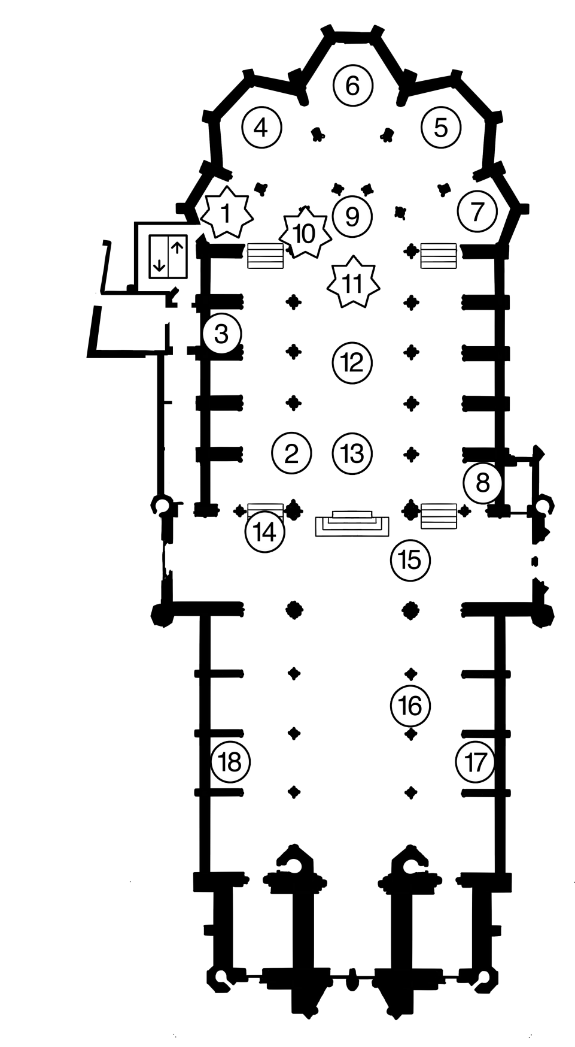



: don’t miss!